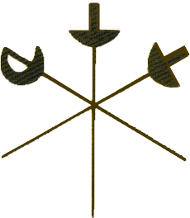OFFICIAL NOTIFICATION
OF
HUNTINGDONSHIRE FENCING CLUB
2021 AGM.
SUNDAY 15TH AUGUST 2021
STARTING AT 3pm
THE MEETING WILL BE HELD VIA ZOOM
We encourage all members to participate as this is your club and you should have your say on how it is run.
You may stand for any of the committee positions but in particular we are looking for a club secretary as Fran Nottingham has stepped down.
Attached is a draft agenda
Any points you wish to raise at the meeting should be submit by the 8th August 2021 so it maybe added to the agenda, send to Mike Ellis.
If you wish to join the AGM please email Mike Ellis so we ensure you are sent the correct invitation to be able to join the ZOOM meeting

