Attached are two photos, the 1st 1982 in the Medway centre. Ivan left front row with John Dennet (one of the club founders), back row, 2nd in from left Andy Luckman, centre Ken Kingham our coach at the time, far right, myself.
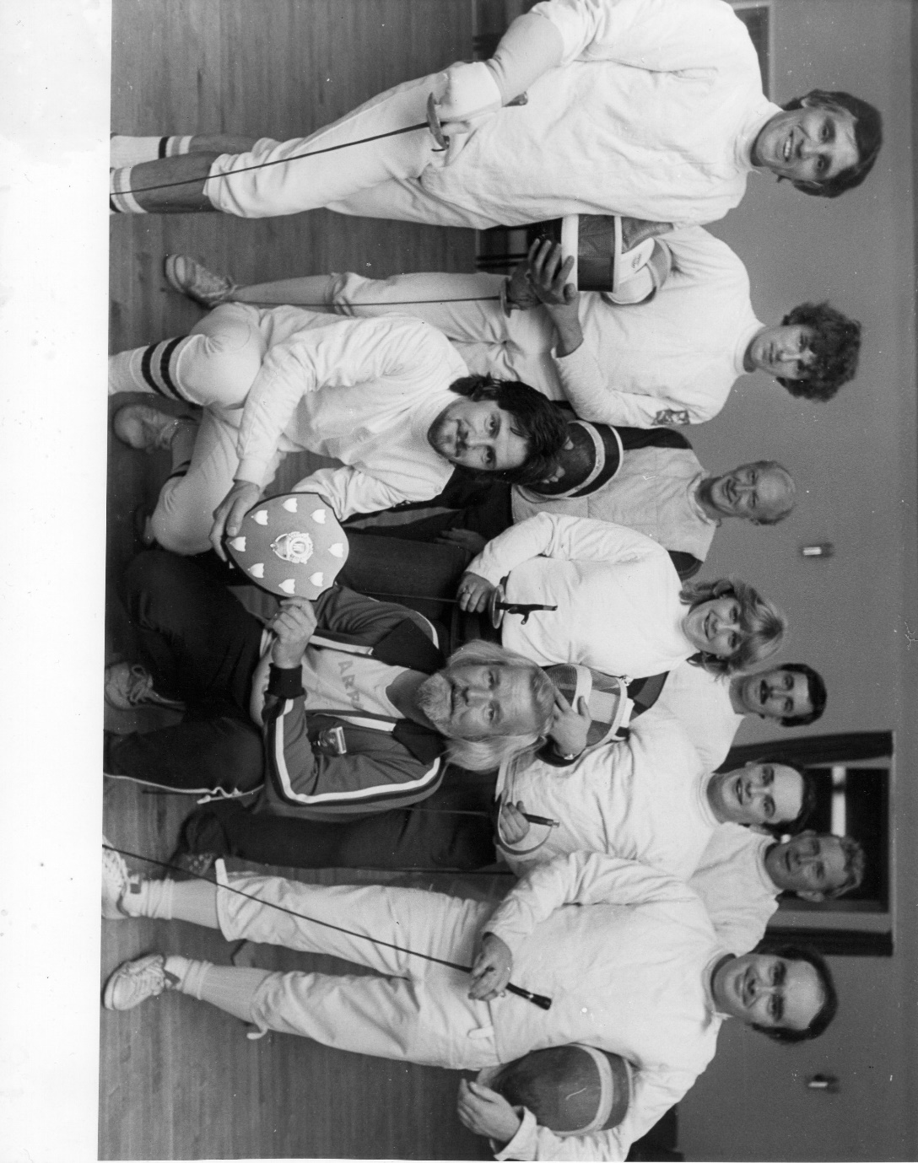

2nd photo, winning team of the 1987 invitation 4 weapon team competition, which is still fenced for.
Left to right, Andy Luckman (M/foil), Clare Walden (W/foil), Ivan ward (Epee), Mike Ellis (Sabre)
